Hello and thank you for download my Asset!

In this package you can drive forklift, raise and drop objects on the shelves. In Asset tuned physics, colliders and the vehicle controller.

- with controller ( acceleration \ turning \ braking, move cargo up\down)

- .fbx models with easy textures

Please don't forget to rate and leave a comment!

Drag prefabs forklift truck

And configure the controller or use standard parameters

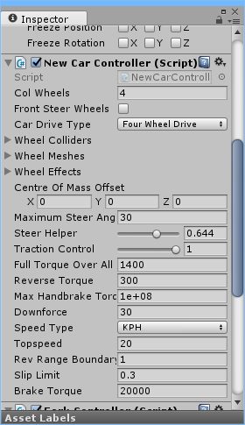

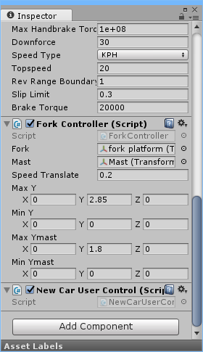

For forklift truck using the optional script:

ForkController.cs - The script for the management platform forklift.

In this script, you can customize the speed settings, the minimum and maximum height of the mast and fork platform.